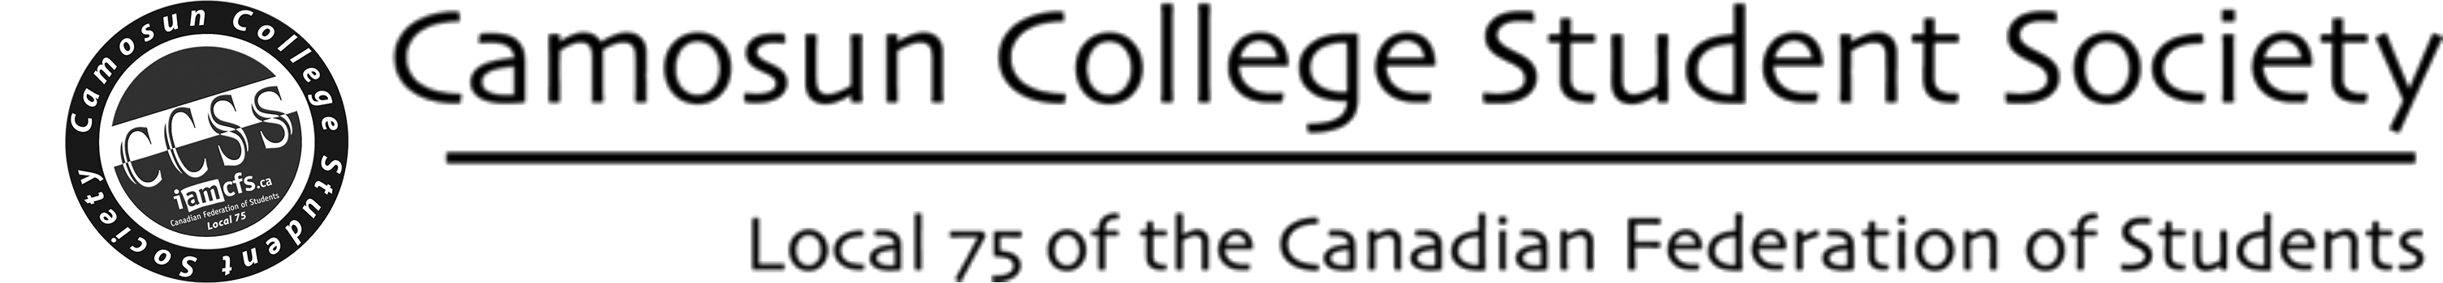

CCSS SERVICE COMPLAINT FORM

This form allows students to file a general complaint to any of the following:

Society Staff: ccss@camosunstudent.org
Elected Students: executive@camosunstudent.org
College Ombudsperson: ombuds@camosun.ca

OPTIONAL FIELDS FOR COMPLAINT PROCESS
Name: Email: Phone:

Requesting follow-up: Y / N Method: Today's Date: / /

Subject of complaint:
Description of the complaint:
How would you like to see this issue resolved:
Thank you for your feedback. Someone will address your issue and will follow-up with you if you selected that choice above. Please understand that not all requests can be met.
This form can be submitted at: http://CamosunStudent.org/clubs/forms/submit

